MGT301 MIDTERM VUSS SOLVED IMP MCQ’S

1. When Olympia Carpets develops new carpets that are highly stain resistant and durable, it must educate consumers about the product's benefits. This activity calls for which one of the following marketing mix variables?
A. Price B. Promotion
C. Distribution D. Product
Reference:
http://www.proprofs.com/quiz-school/quizshow.php?title=mgt301- no4&quesnum=10&showNextQ=no

2. Which one of the following statements by a company chairman BEST reflects the
marketing concept?

A. We have organized our business to satisfy the customer needs
B. We believe that marketing department must organize to sell what we produce
C. We try to produce only high quality, technically efficient products
D. We try to encourage company growth in the market

Reference:
http://www.brainmass.com/homework-help/business/marketing/87074

3. Advertising agencies are an example of which of the following marketing intermediaries?

A. Insurance company B. Financial intermediary
C. Marketing services agency D. Physical distribution firm

Reference:
Marketing service agencies (such as marketing research firms, advertising agencies, media firms, etc.) help the company target and promote its products. Page#43

4. Which one of the following factor is NOT used for measuring the social class?

A. Income B. Number of children in family
C. Occupation D. Education

Reference:
(page 64) but is measured as a combination of occupation, income, education,
wealth, and other variables

5. A marketer has brought same products in the market for all segments without
considering the needs and wants of the customers. Which one of the following strategy is being practiced by the marketer?

A. Undifferentiated marketing strategy B. Differentiated marketing strategy
C. Concentrated marketing strategy D. Custom marketing strategy

Reference:
(page 5-10) http://books.google.com/books?id=tQVizifrtRMC&pg=SA5-
PA10&dq=A+marketer+has+brought+same+products+in+the+market+for+all+segments+without+considering+the+needs+and+wants+of+the+customers&hl=en&ei=ORHTfH_JYnPsgaLp8GVAw&sa=X&oi=book_result&ct=bookthumbnail&resnum=1&ved=0CCkQ6wEwAA#v=onepage&q&f=false

6. Observers have noted a shift from a “me-society” to a “we-society” Which one of the following view reflects this statement?

A. People’s views of themselves B. People’s views of others
C. People’s views of organizations D. People’s views of societies

Reference:
People’s views of others. Observers have noted a shift from a “me-society” to a
“we-society.”

7. Business markets can be segmented on the basis following variables EXCEPT:

A. Personal characteristics B. Operating variables
C. Selling approaches D. Situational factors

Reference:
Businesses segment using variables of operating characteristics, purchasing
approaches, situational factors, and personal characteristics.

8. McDonald’s runs advertisements featuring children, senior citizens, and minority groups. What does this ad show?
A. Company is product oriented.
B. Company considers only environmental factors.
C. Company has several target markets.
D. Company is market oriented

Reference:
Correct Option: C

Explanation:
Children, senior citizens and minority groups in advertisements clearly indicate that McDonald is targetting these very groups. In its own words, "McDonald's aims to offer a friendly, fun environment for everyone to enjoy. We seek to appeal to a wide range of people, from families who love our Happy Meal, to workers grabbing breakfast on-the-go or eating in to enjoy our freshly ground coffee and free WiFi." Option 'C' is hence the most appropriate choice here.

9. XYZ Company purchased Hear Music and began making compilation music CDs to play and sell in its stores. It has also tested new restaurant concepts; XYZ Company is considering which of the following strategies?

A. Product development B. Market development
C. Diversification D. Market penetration

Reference:
1. In 1999, Starbucks purchased Hear Music and began making compilation music CDs to play and sell in its stores. It has also tested new restaurant concepts, such as Circadia in San Francisco. Starbucks is considering _____.
a. new product development
b. market development
c. diversification
d. market penetration
Answer: (c) Difficulty: (2) Page: 49

10. The two dimensions of product quality are:

A. Level and consistency (Chapter no 13 Page no 545 Original Book)
B. Precision and accuracy
C. Level and precision
D. Consistency and precision

11. Chimney Sweeps employs people to clean fireplaces and chimneys in homes and
apartments. The company offers ________ to its customer.

A. product B. idea
C. service D. advice

Reference:
Chimney sweeps inspect, clean, service, repair, and appraise chimneys.
http://www.jobmonkey.com/uniquejobs/chimney-sweep.html

12. Why is the legislation of business considered important?

A. To protect consumers
B. To protect companies from each other
C. To protect the interest of the society
D. All of the given options (Chapter no 3 Page no 110 Original Book)

13. Schools, hospitals, nursing homes, prisons are examples of:

- Institutional Markets (Chapter no 8 Page no 321 Original Book)
- Government Markets
- Consumer Markets
- None of the given options

14. A review of the sales, costs and profit projections for a new product to find out whether they satisfy the company’s objectives refers to which one of the following concepts?

A. Business feasibility B. Feasibility study
C. Business analysis D. Product acceptance

Reference:
Business analysis involves a review of the sales, costs, and profit projections to
find out whether they satisfy the company’s objectives.

15. In the decline stage of the life cycle, there are many options available to companies with respect to the future of their products. If a company decides to reduce various product costs and hope that sales hold up, they have decided to ___________ the product.

A. Reinvent B. Modify
C. Harvest D. Drop

Reference:
Managers may decide to harvest the product (which means reducing various costs and hoping that sales hold up).

16. From the following options, the most complex type of business buying situation is the:

A. Modified rebuy B. System selling
C. Straight rebuy D. New task

Reference:
• New-task buy (the most difficult and complex buying situation), which is the
first-time purchase of a major product.

17. All of the following are characteristics which make up the actual product EXCEPT:

a. Quality level
b. Brand Name
c. Features
d. After-sales services (Chapter no 13 Page no 540 Original Book)

18. Mr. ABC has just brainstormed a large number of ideas for adding new products and services after visiting several buying fairs. The owners will begin the first idea-reducing stage to select the good ideas and drop the poor ones. What is another name of idea reducing stage

a) Idea generation b) Idea screening PG 242
c) Product concept d) Concept development

19. Developing and maintaining a strategic fit between the organization’s goals and
capabilities and its changing marketing opportunities represent which one of the
following concept?

a. Marketing objectives b. Strategy planning PG 28
c. Marketing activities d. Corporate strategies

20. Which one of the following options represents the collection of businesses and products that make up a company?

a. Strategic business unit b. Mission statement
c. Strategic plan d. Business portfolio

Reference:
7. The collection of businesses and products that make up a company is
called its _____.
a. strategic business unit
b. mission statement
c. strategic plan
d. business portfolio
Answer: (d) Difficulty: (1) Page: 44

21. Marketers are interested in the roles and influence of the husband, wife and children on the purchase of different products and services. Which one of the following segment is being studied by the marketer?

a. Social class b. Opinion leader
c. Reference group d. Family

Reference:
26. The _____ is the most important consumer buying organization in society. Marketers are interested in the roles and influence of the husband, wife, and children on the purchase of different products and services.
a. family
b. social class
c. opinion leader
d. information search
e. reference group
(Answer: a; p. 134; Easy)

22. Which of the following is the most basic cause of a person’s wants and behavior?

a. Culture b. Brand personality
c. Cognitive dissonance d. New product

Reference:
10. _____ is(are) the most basic cause of a person’s wants and behavior.
a. Culture
b. Brand personality
c. Cognitive dissonance
d. New product
e. Selective perception
(Answer: a; p. 129; Moderate)

23. In creating research questionnaires, which of the following is good advice for
research specialist to follow?

a. Use care in the wording and ordering of questions (See Picture Below)
b. Questions do not have to be arranged in a logical order
c. Ask personal questions in the middle of the instrument
d. Avoid eye contact as it may confuse the respondents

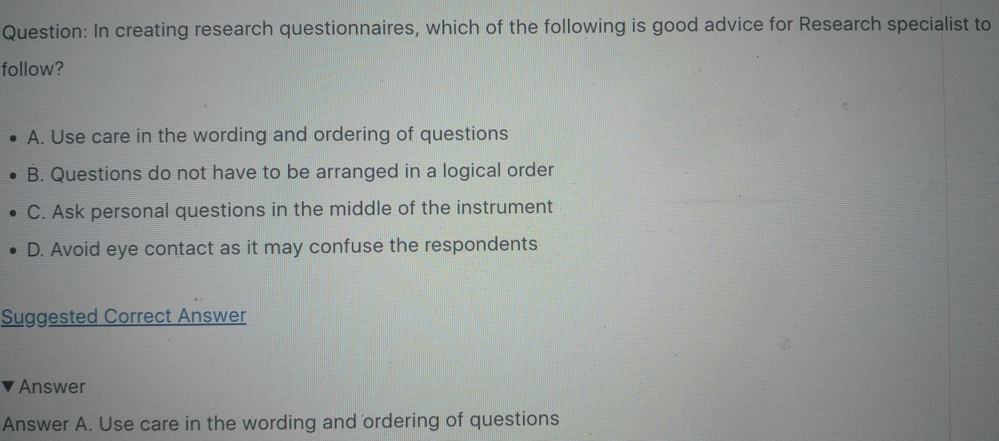

24. Some banks have increased their market share by offering accounts especially for
children in another city. This example illustrates which of the following growth
strategies?

a. Market penetration b. Market development (See picture below)
c. Horizontal diversification d. Conglomerate diversification

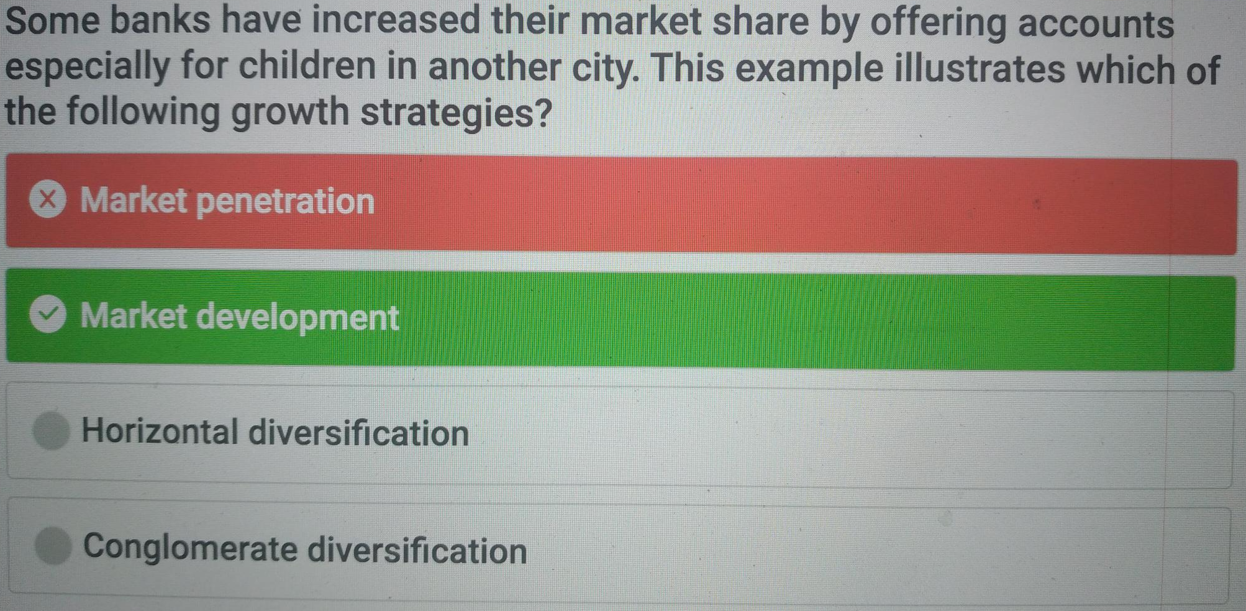

25. Which one of the following concepts is a useful philosophy in a situation when the product’s cost is too high and marketers look for ways to bring it down?

a. Selling concept b. Product concept
c. Production concept d. Marketing concept

Reference:
Page#19 Demand for a product exceeds the supply.
2). The product’s cost is too high and improved productivity is needed to bring it

30. In which one of the following stages of the product life cycle sales fall off and profits stop?

a. Growth b. Introduction
c. Decline d. Maturity

Reference:
(page 107) Decline is the period when sales fall off and profits drop.

31. The company received many ideas for the development of a new product. The company inspected every idea and retained good ideas and dropped the poor ones. In new product development, this stage is commonly known as:

a. Idea generation
b. Idea screening (Chapter no 14 Page no 592 Original Book Read)
c. Concept development and testing
d. Business analysis

32. After concept testing, a firm would engage in which stage for developing and marketing a new product?

a. Marketing strategy development (From Objective Agribusiness Management 3rd Ed By Ritambhara Singh , S.R. Panigrahy, Dr. Sanjiv Kumar) (Chapter no 4 Page no 67 Original Book)
b. Business analysis
c. Product development
d. Test marketing

33. The firms that buy goods and services in order to produce products and services are called:

a. Business markets (Chapter no 8 Page no 327 Original Book)
b. Consumer markets
c. International markets
d. None of the given options

34. The marketing concept expresses the company's commitment to:

a. Organizational goals
b. An integrated company effort

c. Consumer sovereignty (From Sales Management By C.L. Tyagi, Arun Kumar
Chapter no 4 PG 83)
d. All of the given options

35. Mr. A started his business by manufacturing small cheaper cars. As his business
blossomed he decided to manufacture expensive luxury cars to add prestige to his
current products. Mr. A was stretching his product line:

a. Upwards (From Google) b. Downwards
c. Both ways d. None of the given options

36. Within the organization, buying activity consists of two major parts:

a. Buying center and buying decision process (Lecture no 16 Page no 76 Handouts)
- Buying center and consumer decision process
- Selling center and buying decision process
- Selling center and consumer decision process

37. The marketing mix consists of the four P’s product, price, place, and promotion. In this modern marketing era, these tools might be more appropriately named the four Cs: Customer solution, Customer cost, Communication and _____________.

- Customer control b. Convenience (Lecture no 8 Page no 37 Handouts)
- Consideration d. Customer relationship

38. Which of the following is NOT a content of the marketing plan?

- Budget b. Production (Lecture no 8 Page no 38 Handouts)
c. Objective d. Control

39. The digital age will fundamentally change customers’ thinking of convenience, speed, price, product information and service. This new consumer thinking will affect which one of the following businesses?

a. A few businesses b. Every business PG 74
c. Established businesses d. Starting up businesses

40. An American fast food started its business in Pakistan but failed to make a profit. After performing a marketing research the managers found out that there food was not spicy enough. The managers failed to consider which of the following factor?

a. Cultural differences (From 1011 Pages File) b. Lifestyle differences
c. Beliefs and attitudes d. Social class

41. Companies can segment international markets using one or more of a combination of variables. The chief factors that can be used are:

a. Geographic location
- Economic factors
- Political factors
- All of the given options (Lecture no 18 Page no 86 Handouts)

42. Through which process individuals and groups obtain what they need and want by
creating and exchanging products and value with others?

a. Production process b. Marketing process
c. Managerial process d. Accounting process

Reference:
Marketing is defined as “a social and managerial process by which individuals and groups obtain what they need and want through creating and exchanging products and value with others.”

43. Which one of the following phrases reflects the marketing concept?

a. The supplier is a king in the market
b. Marketing should be viewed as hunting not gardening
c. This is what I make, won t you please buy it?
d. This is what I want, won’t you please make it?

Reference:
According to the famed father of Direct Marketing, Lester Wunderman, which of the following phrases reflects the marketing concept?
a. The supplier is king.
b. Marketing should be viewed as hunting and not gardening.
c. This is what I make, won’t you please buy it?
d. This is what I want, won’t you please make it?
Answer: (d) Difficulty (3)

44. The objective of which of the following research is to gather preliminary information that will help define the problem and suggest hypotheses?

a. Descriptive b. Exploratory
c. Causal d. Corrective

Reference:
(page 55) Exploratory research where the objective is to gather preliminary
information that will help to better define problems and suggest hypotheses for their solution.

45. Person’s pattern of living as expressed in his or her psychographics represents which one of the following concept?

a. Personality b. Culture
c. Lifestyle d. Motive

Reference:
http://www.funnelbrain.com/c-284368-persons-pattern-living-expressed-activitesinterests- opioni.html
(Slide 9)
http://docs.google.com/viewer?a=v&q=cache:9bfgZRfx1gUJ:www.imsciences.net/uploads/second-semester/1-Marketing-Consumer-and-Business-Buyer-
Behavior.ppt+pattern+of+living+as+expressed+in+his+or+her+psychographics+represents&hl=en&pid=bl&srcid=ADGEESiZIUQc16O0wGxWrhLKGpHtz3Z0LHWKMQQD7VoAS_uiGm9CjFPtxabgppDKzdsIiloZ1B0Q4d7dB53GsRpOqoYZC2s3Ak2eQGDjdoMpgRviX4nw2GusqoBT0qd7qg7LdCEChRP&sig=AHIEtbTswbkMNnt_RQ7TZSgSOZlNOKmdmg&pli=1

46. Customer service is another element of product strategy. The first step is to survey
customers periodically to assess the value of current services and to obtain ideas for new ones. From this careful monitoring, marketer has learned that buyers are very upset by repairs that are not done correctly the first time. What is the name of these types of services?

a. Brand equity services b. Product support services
c. Social marketing services d. Unsought product services

Reference:
Chapter 9
1. Customer service is another element of product strategy. The first step is to
survey customers periodically to asses the value of current services and to
obtain ideas for new ones. From this careful monitoring, Cadillac has learned
that buyers are very upset by repairs that are not done correctly the first time.
What is the name of these types of services?
a. brand equity services
b. product support services
c. social marketing services
d. unsought product services
(b; Challenging; p. 288)

47. Which one of the following concept BEST represents the involvement of management and employees in the continuous improvement of the production of goods and services?

a. Total quality management b. Marketing management
c. Customer relationship management d. Knowledge management

Reference:
http://books.google.com/books?id=4OgyJ740KxMC&pg=PA193&dq=involvement+of+management+and+employees+in+the+continuous+improvement+of+the+production+of+goods+and+services&hl=en&ei=L5WDTf6K8fPrQewqp3LCA&sa=X&oi=book_result&ct=result&resnum=2&ved=0CC0Q6AEwAQ#v=onepage&q=involvement%20of%20management%20and%20employees%20in%20the%20continuous%20improvement%20of%20the%20production%20of%20goods%20and%20services&f=false (page 193)

48. Suppose marketers at Lever Brothers are trying to determine whether the use of coupons for detergent was the reason for a sales increase in a particular store. What type of study conducted to answer this question?

a. Exploratory b. Descriptive
c. Causal d. Qualitative

Reference:
(Q#5) http://www.scribd.com/doc/27111863/Marketing-Research-and-Information-Systems-Section-A

49. Companies are refraining to use poisonous gases in the manufacturing of their products to prevent damage to the environment. The companies are trying to follow:

a. Production Concept b. Product Concept
c. Marketing Concept d. Societal Marketing Concept

Reference:
(page 51)
http://books.google.com/books?id=PnERvpCI5QYC&pg=PA51&dq=societal+marketing+concept&hl=en&ei=wkGBTZyhMsPhrAfUlNGyBw&sa=X&oi=book_result&ct=result&resnum=2&sqi=2&ved=0CC0Q6AEwAQ#v=onepage&q=societal%20marketing%20concept&f=false

50. Which of the following is not one of the 4 types of SBUs described by the Boston Consulting Group approach?

a. Cash Lion (Lecture no 44 Page no 224 Handouts) b. Cash Cow
c. Star d. Dog

51. Manufacturers of surf excel are successful in making their product occupy a
desirable place in the hearts of its customers. Now surf excel is considered as a
powerful all purpose family detergent. The marketers have successfully
___________ its product.

a. ≈ Differentiated b. ≈ Targated
c. ≈ Positioned d. ≈ Segmented

Reference:
P#88,,Tide is positioned as a powerful, all-purpose family detergent; In
the automobile market, Toyota and Subaru are positioned on economy,
Mercedes and Cadillac on luxury Consumers are overloaded with
information about products and services.

52. The factors such as the buyer’s age, life-cycle stage, occupation, economic situation, lifestyle, personality and self-concept that influences buyer’s decisions refers to which one of the following characteristic?

a. Personal characteristics b. Psychological characteristics
c. Behavioral characteristics d. Demographical characteristics

Reference:
REF: http://wps.pearsoned.co.uk/wps/grader

53. A period of rapid market acceptance and increasing profits refers to which of the
following stages of the product life cycle?

a. Decline b. Growth
c. Maturity d. Introduction

Reference:
Growth is a period of rapid market acceptance and increasing profits.
http://www.zainbooks.com/books/marketing/principles-of-marketing_22_product-lifecycle.html

54. Which of the following options refers to “New Products”?

a. Product modifications b. Product improvements
c. New brands that a firm develops d. All of the given options PG 101

55. The managers of a firm are providing all the facilities and assistance that a customer demands. As a result of their efforts the customers are satisfied and the firm is enjoying huge profits. The efforts of the manager are considered as part of:

a. Customer Relationship Management (From 1011 Pages File)
b. Total Quality Management
c. Supply chain Management
d. Customer Acknowledgement

56. Which one of the following factor indicates "the name, term, sign, symbol, design or a combination of these that differentiate the product of one seller or group of sellers from the other sellers"?

a. Brand b. Package
c. Label d. Style

Reference:
A brand is a name, term, sign, symbol, or design, or a combination of these, that
identifies the maker or seller of a product or service pg no 96

57. Toyota Xli has fulfilled all the expectations that were advertised during the launch of the product. Thus the customers buying Toyota Xli must be:

a. Satisfied (Common Sense) b. Surprised
c. Disappointed d. Dissatisfied

58. Which of the following is not an example of a convenience product?

a. Clothing (From Google) b. Magazines
c. Tooth paste d. Soft drinks

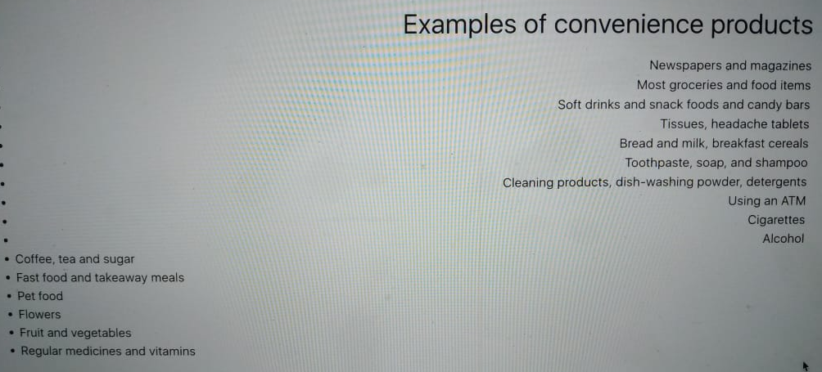

59. Mr. X wants to conduct a marketing research. He has limited resources and he needs to collect large amounts of information. Mr. X should adopt which of the following contact method?

a. Mail questionnaire (Read Lecture no 13 Page no 57 Handouts)
b. Telephone interviewing
c. Personal interviewing
d. Computer interviewing

60. The steps comprising the marketing control process in ascending order are:

- Measure performance – evaluate performance – corrective action – set goals
- Corrective action – set goals – measure performance – evaluate performance
- Set goals – measure performance – evaluate performance - corrective action (Read Lecture no 8 Page no 39 Handouts)
- Set goals – measure performance – corrective action - evaluate performance

61. Which one of the following statements is an example of a problem that may arise in the implementation of the marketing concept?

a. The marketer cannot satisfy all the marketing segments (From Google See Picture Below)
b. Consumers do not understand what the marketing concept is
c. Dealers do not support the marketing concept
d. A product may fit the needs of too many segments

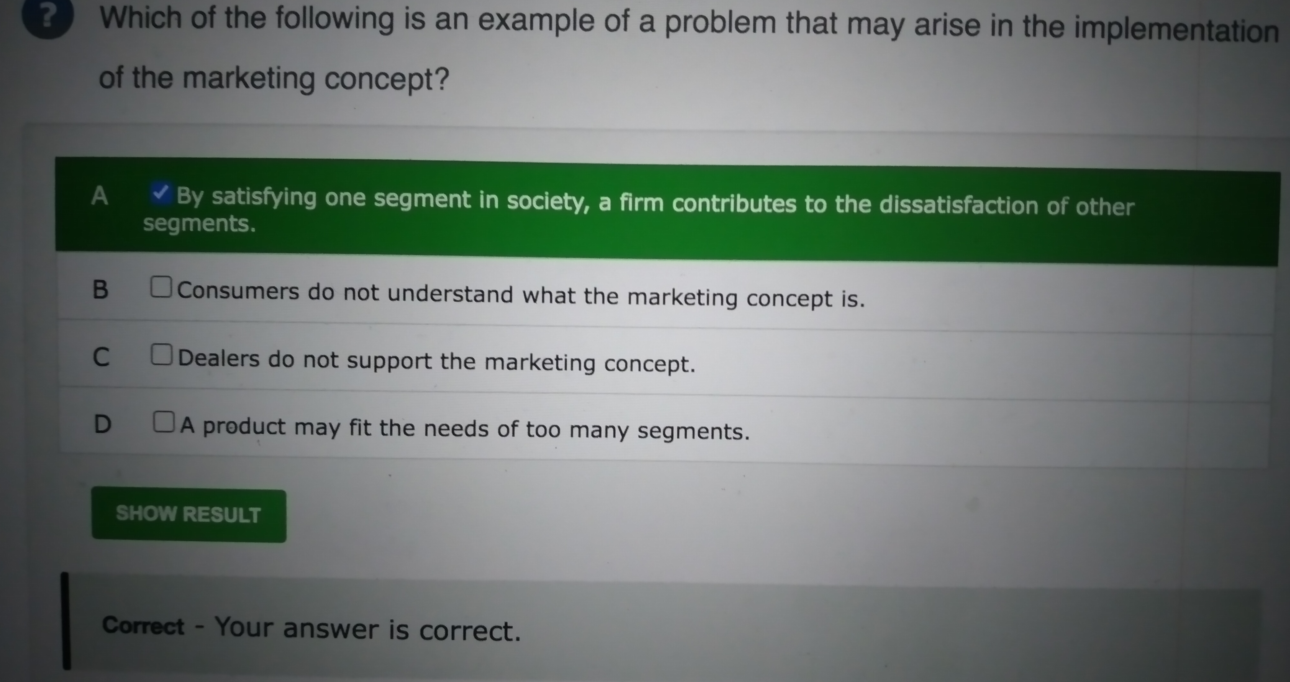

62. When a company introduces additional items in a given product category under the same brand name, such as new flavors, forms, colors, ingredients, or package sizes refers to which of the following steps?

a. Line extensions b. Product mix
c. Service variability d. Service intangibility

Reference:
(page 98) line extensions. Existing brand names are extended to new forms, sizes, and flavors of an existing product category

63. People are expected to perform activities according to the persons around them. These activities reflect which one of the following concept?

a. Motive b. Role
c. Lifestyle d. Tradition

Reference:
A role consists of the activities people are expected to perform according to the
persons around them.
http://faculty.sheltonstate.edu/~tmajor/BUS285/Outlines/ch05outlilne.pdf

64. If ABC Ltd knows that its market share in Pakistan has dropped 13 percent in the first quarter of the year but does not know what might have contributed to this decline, it is in which stage of the marketing research process?

a. Hypothesis development b. Symptom identification
c. Problem identification d. Data interpretation

Reference:
http://www.scribd.com/doc/27111863/Marketing-Research-and-Information-
Systems-Section-A

65. It is important to note that research objectives must be translated into which of the
following?

a. Marketing goals b. Information needs
c. Dollar amounts d. Results that justify the means

Reference:
(page 56)Determine specific information needs. In this step research objectives are translated into specific information needs

66. In which of the following product life cycle stages, sales are zero and the company’s investment costs mount?

a. Product development PG 106 b. Introduction
c. Growth d. Maturity

67. The major marketing research tool for gaining insights into consumer thoughts and feelings is:

a. All of the given options b. Focus group interviewing
c. Telephone interviewing d. Online interviewing

Reference:
(page100)
http://books.google.com/books?id=Lx5dxjc_Kq0C&pg=PA100&dq=major+marketing+research+tool+for+gaining+insights+into+consumer+thoughts&hl=en&ei=jiyGTcLQAoGKuAO1yIi9CA&sa=X&oi=book_result&ct=result&resnum=4&ved=0CD0Q6AEwAw#v=onepage&q&f=false

68. The ultimate aim of customer relationship management is to produce __________.

a. Sales Volume b. Customer Equity (From Google)
c. Market Share d. Profits

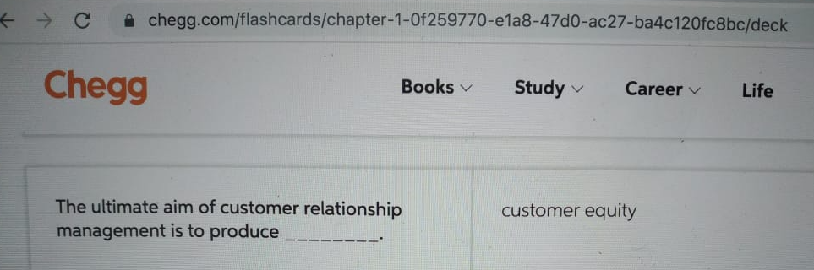

69. The _____ is/are the most important consumer buying organization in society.

a. Family b. Reference Group
c. Friends d. Teachers

Reference:
26. The _____ is the most important consumer buying organization in society. Marketers are interested in the roles and influence of the husband, wife, and children on the purchase of different products and services.
a. family
b. social class
c. opinion leader
d. information search
e. reference group
(Answer: a; p. 134; Easy)

70. Which one of the following environment is made up of institutions and other forces affecting society’s basic values, perceptions, preferences and behaviors?

a. Cultural environment b. Fictitious environment
c. Natural environment d. Political environment

Reference:
P#47,,The cultural environment is made up of institutions and other forces that
affect society’s basic values, perceptions, preferences, and behaviors.

71. The Planning which is concerned with translating the general goals and plans developed by strategic managers into objectives that are more specific is called:

a. Strategic Planning b. Tactical Planning
c. Operational Planning d. Mission Planning

Reference:
tactical Planning: Tactical planning is concerned with translating the general goals and plans developed by strategic managers into objectives that are more specific and activities.

72. Which method of research can be used to obtain information if people are
unwilling or unable to provide?

a. ≈ Observations b. ≈ Focus groups
c. ≈ Personal interviews d. ≈ Questionnaires

Reference:
(page 56) Observational research can be used to obtain information that people are unwilling or unable to provide.

73. Which one of the following is an alternative to product line stretching that adds more items within the present range of the line?

a. Product mix b. Interactive marketing
c. Product line filling (From Google) d. Co-branding

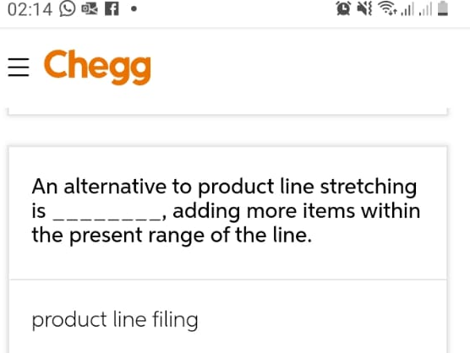

74. Launching a product in a small part of the market is called:

a. Test marketing PG 180 b. Product testing
c. Marketing analysis d. All of the given options

75. Brand created and owned by a reseller of a product or service is called:

a. National Brand b. Private Brand (Lecture no 20 Page no 97 Handouts)
c. License Brand d. Co-branding

76. The propensity for people to screen out most of the information to which they are exposed is called:

a. Selective Attention b. Selective Retention
c. Selective Distortion d. None of the given option

Reference:
The tendency for people to screen out most of the information to which they are
exposed is called Selective Attention
http://books.google.com.pk/books?id=Lx5dxjc_Kq0C&pg=PA207&lpg=PA207&dq=Which+of+the+following+are+the+products+bought+by+individuals+and+organizations+for+further+processing+or+for+use+in+conducting+a+business%3F&source=bl&ots=xbEGBr0aWO&sig=EPiR9ZLiXk1iATwkita2wgUAOCc&hl=en&ei=JSkSTf2_NouOjAekkKn2BQ&sa=X&oi=book_result&ct=result&resnum=5&ved=0CDMQ6AEwBA#v=snippet&q=tendency%20for%20people%20to%20screen%20out%20most%20of%20the%20information%20&f=false

77. A new product is a good, service, or idea that is perceived by some potential customers as new. The marketers investigate that how the customers learn about new product and make a decision to buy. Which one of the following option reflects this statement?

a. New product recognition b. Adoption process
c. Variety-seeking buying behavior d. Quality assessment

Reference:
67. A new product is a good, service, or idea that is perceived by some potential
customers as new. Our interest is in how consumers learn about products for the
first time and make the decision to buy them. This is called the _____.
a. new product recognition
b. adoption process
c. variety-seeking buying behavior
d. information search
e. quality assessment
(Answer: b; p. 146; Moderate)

78. Environmental groups are included in which of the following publics?

a. Citizen-action publics b. Media publics
c. Government publics d. Local publics

Reference:
(page63)
http://books.google.com/books?id=Lx5dxjc_Kq0C&pg=PR28&dq=principle+of+marketing+kotler+13th&hl=en&ei=JjqCTZSvDs_IrQfhqc3dCA&sa=X&oi=book_result&ct=result&resnum=8&ved=0CFUQ6AEwBw#v=onepage&q=Environmental%20groups%20&f=false

79. When competition is intense among manufacturers, the buyers have more options to switching the product. This situation is represented in Porter’s model as:

a. Threat of new entrants
b. Bargaining power of buyers (Lecture no 5 Page no 22 Handouts)
c. Bargaining power of suppliers
d. Rivalry among competing firms

80. A threat is an unfavorable situation and seen as key impediments to the firm’s current and desired position. Which one of the following statements can be treated as threat to a firm?

- Firm’s inability to penetrate market

b. The entrance of new competitors in the market (From Strategic

Management: Formulation, Implementation and Control (Special ...
By PEARCE Chapter no 6 Page no 162 Book)
- Differentiated products or services
- Cost advantages due to economy of scale

81. Dell Computers formed an alliance with Intel Processors creating marketing synergy. Thus two companies form an alliance to work together, creating a new marketing opportunity. This is an example of:

a. National Brand b. Private Brand
c. License brand d. Co-branding

Reference:
Co-branding, also called brand partnership[1], is when two companies form an
alliance to work together, creating marketing synergy. As described in Co-Branding: The Science of Allianc
http://en.wikipedia.org/wiki/Co-branding

82. Reference group, family and status all play a major role in shaping the buying
behavior of individuals. All these factors are grouped into which of the following?

a. Cultural b. Social
c. Personal d. Business

Reference:
Social Factors
A consumer's behavior also is influenced by social factors, such as the consumer's small groups, family, and social roles and status

83. Which of the following is NOT a step in the strategic planning process?

a. Defining the company mission
b. Planning marketing and other functional strategies
c. Setting company objectives and goals
d. Setting pricing policies

Reference:
Q#3http://wps.pearsoned.co.uk/ema_uk_he_harker_mktgintro_1/127/32607/8347621.cw/content/index.html

84. Three main strategies for intensive growth are market penetration, product
development and _________

a. Product improvement b. Market saturation
c. Market growth d. Market development

Reference:
The set of strategies included in intensive strategies are:
1. Product development
2. Market penetration
3. Market development
http://www.mba-tutorials.com/strategy/1112-intensive-strategies.html

85. The purpose of idea generation is to create a _____ of ideas. The purpose of
succeeding stages is to _____ that number.

a. ≈ Small number; reduce b. ≈ Small number; increase
c. ≈ Large number; increase d. ≈ Large number; reduce

Reference:
(page 102) The purpose of idea generation is to create a large number of ideas. The purpose of the succeeding stages is to reduce that number.

86. The first step in the marketing control process is BEST described when the marketer performs which of the following activities?

a. Evaluates performance b. Measures performance
c. Sets specific goals d. Takes corrective action

Reference:
P#39,,Marketing Control
1). Set specific goals
2). Measure performance
3). Evaluate Performance
4). Take corrective action

87. Building, keeping and growing profitable value-laden relationships with all customers of a company refers to which one of the following concept?

a. Customer lifetime value
b. Customer perceived value
c. Customer relationship management
[Answer: (c) Difficulty: (1) Page: 16]
d. Societal marketing

88. Konica is aiming its Cool Cam camera at teenagers. Which one of the following is
reflecting Teenagers?

a. Target market b. Focus group
c. Target audience d. Segmentation

Reference:
(Q#15)http://www.scribd.com/doc/27111819/An-Overview-of-Strategic-Marketing-Section-B

89. A company may review sales histories and conduct surveys of market opinion in the __________ stage.

a. Business analysis (Lecture no 45 Page no 232 Handouts)
b. Idea generation
c. Idea screening
d. Marketing strategy development

90. Neighborhood residents and community organizations comprise part of a firm’s:

a. Local Publics b. General Publics
c. Governmental Publics d. Financial Publics

Reference:
(page 43)Local publics--includes neighborhood residents and community
organizations

91. Marketing management functions in ascending order are:

a. Control – implementation – market planning
b. Market planning – control – implementation
c. Implementation – control – market planning
d. Marketing planning – implementation – control

Reference:
(page 14) Marketing Management is defined as the analysis, planning,
implementation, and control

92. A movie was greatly promoted as having a lot of actions and special effects. When the people went to see the movie it was not according to the expectations of the people. In this case the people were:

a. Satisfied b. Dissatisfied (From 1011 Pages File)
c. Overjoyed d. All of the given options

93. Which one of the following is a chief goal of the implementation function in marketing process?

a. Develops marketing plans b. Turns plans into actions
c. Takes corrective actions d. Develops strategic plans

Reference:
http://www.zainbooks.com/books/marketing/principles-of-marketing_10_marketingprocess.html
Marketing Implementation is the process that turns marketing plans into marketing actions in order to accomplish strategic marketing objectives

94. Which one of the following steps is NOT a part of marketing process?

a. Analyzing marketing opportunities b. Selecting target market
c. Designing the business portfolio d. Develop marketing mix

Reference:
The marketing process consists of four steps: analyzing market opportunities;
developing marketing strategies; planning marketing programs, which entails
choosing the marketing mix (the four Ps of product, price, place, and promotion);and organizing, implementing, and controlling the marketing effort. Marketing is the organizational function charged with defining customer targets and the best way to satisfy needs and wants competitively and profitably.pg no 6

95. An organization with several product lines has which one of the following mix that
consists of all the product lines and items which a particular seller offers for sale?

a. Product mix b. Brand mix
c. Consumer mix d. Packaging mix

Reference:
A product mix (or product assortment) consists of all the product lines and items
that a particular seller offers for sale.
http://www.mbanotesworld.in/2008/05/product-mix-product-line.html

96. Experimental research is best suited for gathering which of the following information?

a. Unknown b. Causal (page#56)
c. Complicated d. Interactive

REF:
http://docs.google.com/viewer?a=v&q=cache:ZEdqkI3huJsJ:140.114.53.170:808
0/StudentProject/NTUTProject/Projects/Others/AKMAI8_IRCD/content/Chapt
er_04/Assess/TIF/armstrong_mai08_tif_04.doc+ABC+Research+Group+must+g
uard+against+problems+during+the+implementation+phase+of+marketing+res
earch+for+its+clients.+Typically,+management+will+not+encounter+which+of+
these+problems%3F&hl=en&gl=pk&pid=bl&srcid=ADGEESgUEoiUJ7AWSP4602mFeCCogQYPUX9fyciO42USLdBtoxY_l3_2iOrw2feX7h_V4cRnCMACf1VlA0g5ooZRFje7TjiWMFEhu1Unlf2IauSJ5VhU4XqmBV5GyJVCW0bSH_t0Fd&sig=AHIEtbT4EQVZbl3wTzgAImOA9elgYmJdTQ

97. Which one of the following are the MOST useful source of speedier and more
comprehensive information?

► Suppliers reports ► Media reports
► Company reports ► Industry reports

Reference:
(page 52)Many companies have developed advanced computer-based internal reports
systems to allow for speedier and more comprehensive information.

98. The consumer decides to make use of the product on a regular basis. Which one of the following concepts BEST describe it?

a. Awareness b. Interest
c. Trial d. Adoption (Lesson no 15 Page no 74 Handouts)

99. Modern University of Technology purchases printing papers on the regular basis without any modification in the purchase order. It is showing which of the following buying situation?

a. Modified rebuy b. Straight rebuy (Lesson no 16 Page no 76 Handouts)
c. Modified straight rebuy d. Consumer buy

100. A company XYZ is going to introduce a new type of electrical cable which is resistant to fire, the management has to decide the various segments to market the cable. The factor(s) involved in evaluating various market segments is(are):

a. Segment size and growth
b. Segment structural attractiveness
c. Company objectives and resources
d. All of the given options. (Read Evaluating Market Segments Lecture no 18 Page no 86 Handouts)

101. An Insurance Company observes a sudden increase in the number of farmers seeking flood insurance in Pakistan due to major floods in India, Which one of the following is representing flood situation for the company?

► Marketing opportunity ► Marketing strategy
► Marketing concept ► Marketing threat

Reference:
http://www.d17.net/farminsurance/mbaquestionferinfarminsurancesawasuddenincreasethenumberoffarmer

102. Which of the following is NOT one of the bases of segmentation?

a. Geographic b. Demographic
c. Income (Lesson no 17 Page no 84 Handouts) d. Physiological

103. Tissue papers, ball points, salt, pepper and soft drinks are all products which are grouped under:

a. Convenience Products (From Google See Picture Below) b. Shopping Products
c. Specialty Products d. Unsought Products

104. Which of the following models was given by Mr. Michael Porter?

a. GE model b. The BCG model
c. Five forces model d. Ansoffs matrix

Reference:
Porter's Five Forces is a business analysis model that helps to explain why various industries are able to sustain different levels of profitability. The model was published in Michael E. Porter's book, "Competitive Strategy: Techniques for Analyzing Industries and Competitors" in 1980.

UNSOLVED MCQ’S

105. The 4 P’s of marketing are product, price, place and promotion. Marketer’s also consider other P’s which are:

a. People and Processes b. People and Positioning (Not Sure)
c. Positioning and Packaging d. All of the given options

106. It is usually said that about 50% of total product costs are marketing costs. Let’s suppose a chocolate bar costs Rs.50. If all the other factors are kept constant, what will be marketing cost of that bar?

a. Rs.40 b. Rs.30 c. Rs.25 d. Rs.15

NOT SURE BUT I THINK
Marketing Cost = Total product costs are marketing costs x chocolate bar costs
Marketing Cost = 50% x 50 = Rs.25 Answer (Not Sure)

107. Miss. X is a working mother. In the house she has to purchase clothes for the baby, buy groceries and in the company she is a brand manager. Thus the various functions that Miss. X performs at the house and in the company are considered as:

a. Role and Status b. Social Class (Not Sure)
c. Groups d. None of the given options

108. Who comprises the consumer market?

- The government institutions that buy or acquire goods or services (Not Sure Read Lecture no 28 Page no 132 Handouts)
b. The private companies that buy or acquire goods and services
c. The individuals who buy or acquire goods and services
d. The manufacturers who buy or acquire raw material

107. When does the product growth stage occur?

a. After the product satisfies the market b. After the product passes concept testing
c. Before the product starts making profits d. None of the given options (Not Sure)

108. Which of the following statements regarding the natural environment is FALSE?

► Weather has become less intense in the previous few years (not sure)
► Increased pollution is a major concern for marketers today
► Global warming is a major issue for marketers to deal with today
► The threat of governmental intervention in natural resource management is a
major issue for marketers

109. FMCG (Fast moving consumer goods) company generally practices:

a. All of the given options (Not Sure) b. Mass marketing
c. Segment marketing d. Niche marketing

110. KFC not only serves Coca-Cola in its restaurants but also receives marketing support. In this scenario, Coca-Cola is a:

a. Reseller b. Financial Intermediary
c. Marketing Intermediary (Not Sure) d. Physical Distribution Firm

111. Ahmed is interested in buying a new laptop. Since a laptop is costly he looked at various brands of laptops, surveyed various websites to get the relevant information about each type of laptop. This is an example of:

a. Complex Buying Behavior
b. Variety Seeking Buying Behavior (Not Sure)
c. Dissonance Reducing Buying Behavior
d. Habitual Buying Behavior

112. Cigarette manufacturers are printing warning labels on the cigarette packs, indicating that smoking is injurious to health. Cigarette manufacturers are practicing:

a. Societal Marketing b. Health Marketing
c. Safety Marketing (Not Sure) d. Niche Marketing

113. XYZ Company has been manufacturing Pedestal fans for past 20 years. Now XYZ Company is interested in making Micro wave ovens. The company is considering which one of the following strategies?

a. Diversification b. Market Penetration
c. Market Development d. Product Development

114. Ali is well-versed in computer technology and reads all the latest information on electronics. He also has a very charming and charismatic personality, so when he recommends certain equipment, other people tend to follow his advice. Ali is a(n) _____.

a. Opinion leader (not sure) b. Important
c. Charismatic d. All of the given options

115. Which of the following is NOT one of the characteristics of the American family?

a. Having more children (Not Sure) b. Marrying later
c. More working women d. Number of non family households is increasing

